This document is merely to point out the differences in confessional count numbers between my findings and the official numbers posted on Survivor Sucks. The guidelines I use can be found [here](https://docs.google.com/document/d/18ofsPiVWxSejzSjEGlU8KEx4Og2ddEJScCV23RsCPIA/edit?usp=sharing).

**Survivor Sucks Season 22 Counts** ([link](https://goo.gl/photos/DPfREGdvVbE5nsbA6))

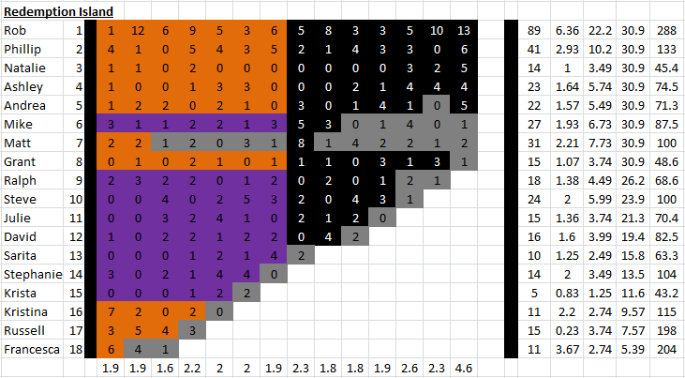

**My Season 22 Counts** ([link](https://goo.gl/photos/E3tYSpv2Anh5eFXZ9))

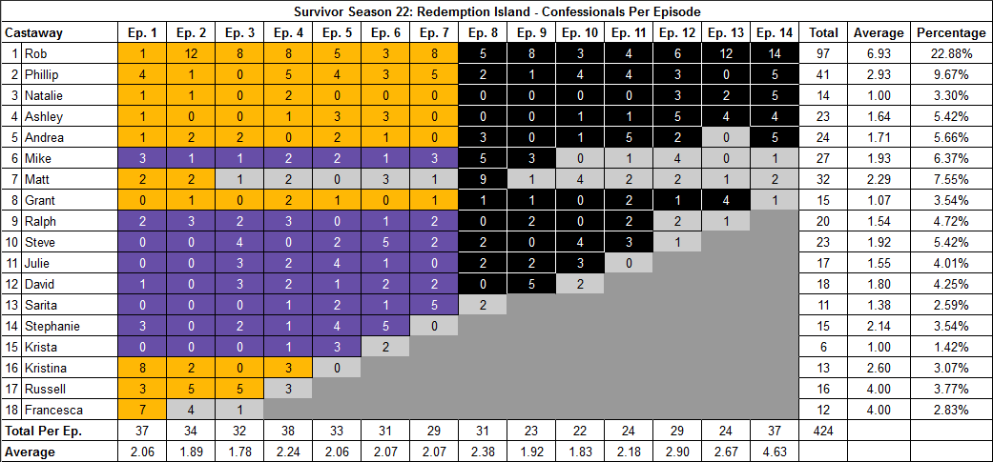

[Survivor Sucks Season 22 thread](http://survivorsucks.com/topic/78729).

**Note:** For Redemption Island themed seasons, I count confessionals post-TC, once castaways arrive at RI, which is a main difference from the guidelines used on Survivor Sucks.

**Differences**

[Episode 01](https://docs.google.com/document/d/12cAud8FTSgBcqboKcj2oAf2RgFbVYOqMHoA2J4QJG6Y/edit?usp=sharing)

* **Kristina: 8 (+1)** Confessional #34 is an on-the-fly confessional at camp (shelter) where Kristina talks directly to the camera. Kristina’s chyron is visible on-screen. Also, confessional #35 is a consecutive Kristina confessional in the same setting and a direct continuation of the previous confessional (no chyron this time) with a 16s gap.
* **Francesca: 7 (+1)** Confessional #37 is a RI confessional.
* **Note:** Confessional #12 has Mike giving an on-the-fly confessional at camp while building the shelter and a visible Ralph on the background. Mike’s chyron is visible on-screen.

[Episode 03](https://docs.google.com/document/d/1JyfZXMZ-5HVJOBw6o_yTlIh07hZF3YFLnGwa8RVh70Q/edit?usp=sharing)

* **David: 3 (+1)** In this episode, I counted 3 confessionals for David instead of the established 2. There are no significant time gaps.
* **Rob: 8 (+2)** Rob has a sequence where he is looking for the HII (#22-25). In it, there are various 10s+ gaps that raises his count for this episode. Also, confessional #24 is an on-the-fly confessional in which Rob walks through the jungle and narrates to the camera and what he says is subtitled. Some may disregard this as a confessional.
* **Russell: 5 (+1)** Confessional #32 is a RI confessional.

[Episode 04](https://docs.google.com/document/d/1VrNtrnYT3lBQ0geR5C_K7qwnZ3Y5YBIiGlUe4UQ-2do/edit?usp=sharing)

* **Ralph: 3 (+1)** Confessional #9 has a 10s gap.
* **Rob: 8 (-1)** Confessional #18 has on-the-fly elements that I included. Because of this, I got -1 less confessionals. If the on-the-fly segments were ignored, then Rob would have a count of 9 for this episode as previously established. Below, I will break down confessional #18 in parts:
  + - [**start of confessional #18]** (→ 17:26) I'm digging through rocks. I'm climbing trees. I'm looking everywhere. And I'm having a really tough time. So I just started searching from tree to tree. At this point, I've already been gone for fifteen minutes. I need to get back to the beach. Otherwise, it going to look suspicious. You know, there's probably about forty trees in our immediate area. And I think it was maybe thirty-eight or thirty-nine, I finally looked up. (← 18:00)
    - [**start of on-the-fly segment**] (→ 18:08 = 8s gap) Ding-Ding! Yeah, baby, maybe I learned something since last time. (← 18:15 = 7s) [**end of on-the-fly segment**]
    - (→ 18:16 = 1s) As for my plans for it, right now, I'm not sure. But one thing I do know is that with this Immunity Idol, this time I'm going to make it 39 days and win. [**end of confessional #18**]
  + As you can see, the total gap of the on-the-fly segment (18:00 → 18:16) is way over the 10s+ mark. If the on-the-fly segment was not included, this would yield an additional confessional for Rob starting at the 18:16 time mark and would bring his count to 9 as originally established.
* **Kristina: 3 (+1)** Confessional #38 is a RI confessional.

[Episode 05](https://docs.google.com/document/d/1B9ictritVz6GhgY9t56PMPkViKOsGoLvZO_o4gcsym4/edit?usp=sharing)

* **Krista: 3 (+1)** Confessional #33 is a RI confessional.
* **Note:** At around the 18:56 mark, Stephanie is looking directly at the camera and talking to it as she chops vegetable. I debated whether this would count as a confessional. I didn’t count it because as she does so, the camera pans for an instant to Krista as she chuckles reacting to what Stephanie is saying. I analyzed the scene as Stephanie talking to Krista.

[Episode 06](https://docs.google.com/document/d/14Eip8DDH1g0NlS4TrwRVTDej5dwwyw_cDaXkPyTCkG8/edit?usp=sharing)

* **Stephanie: 5 (+1)** Confessional #31 is a RI confessional.

[Episode 07](https://docs.google.com/document/d/1QTuNHU6_4ztaQ5sppyy4Y47JsLScCepK6wIzq06WvAg/edit?usp=sharing)

* **Steve: 2 (-1)** In this episode, I counted 2 confessionals for Steve instead of the established 3. There are no significant time gaps.
* **Rob: 8 (+2)** Confessional #10 has an 11s gap. Besides that, I counted an additional confessional that has no significant time gap and was probably missed in the established count.
* **Sarita: 5 (+1)** Confessional #29 is a RI confessional.

[Episode 08](https://docs.google.com/document/d/1-2pZ-bzrr_71uMMytZRSkIX4WJO41OTHxCpX_oL1lAE/edit?usp=sharing)

* **Matt: 9 (+1)** Confessional #31 is a RI confessional.

[Episode 09](https://docs.google.com/document/d/1__hWCP1sAntR7ldo0oIpk1jKMKEtTNL2fPIq1ewusYY/edit?usp=sharing)

* **Julie: 2 (+1)** Julie has 2 confessionals in this episode, #3 and #18.
* **David: 5 (+1)** Confessional #23 is a RI confessional.

[Episode 10](https://docs.google.com/document/d/1cZV9aNhVHt8yqQH2ya2rU2aK_VpaUzitC0KpcR4crho/edit?usp=sharing)

* **Ashley: 1 (-1)** Ashely only has one confessional in this episode (#19). There are no significant time gaps.
* **Julie: 3 (+1)** Confessional #22 is a RI confessional.

[Episode 11](https://docs.google.com/document/d/1TDxZAASy4zLMdWN8VGXVC2ntDdbb54Fl4h7t_jjIyuw/edit?usp=sharing)

* **Rob: 4 (+1)** Confessional #20 has a 10s gap.
* **Phillip: 4 (+1)** Confessional #5 has a 10s gap.
* **Andrea: 5 (+1)** Confessional #14 has a 10s gap.
* **Grant: 2 (-1)** I only counted 2 confessionals for Grant, #16 and #17. There are no significant time gaps.
* **Ralph: 2 (+1)** Confessional #24 is a RI confessional.

[Episode 12](https://docs.google.com/document/d/1V592v81VjFYPZAD_Fh6-bQO_nqHY-7x0yW5VGUdMHn4/edit?usp=sharing)

* **Rob: 6 (+1)** In this episode, I counted a total of 6 confessionals for Rob instead of the established 5. There are no significant time gaps.
* **Ashley: 5 (+1)** Ashley has 4 consecutive confessionals (7-10) after the tribe gets the Sprint Tree Mail. It seems that those confessionals were counted improperly. Her fifth confessional is #17.
* **Andrea: 2 (+1)** Confessional #29 is a RI confessional.

[Episode 13](https://docs.google.com/document/d/1nvy4cZ7jk3rinAAVZWdjaao8xUpRQey6avJiL2ZJEio/edit?usp=sharing)

* **Rob: 12 (+2)** In this episode, I counted 12 confessionals for Rob instead of the established 10. There are no significant time gaps. Confessional #7 is a voice over.
* **Grant: 4 (+1)** Confessional #24 is a RI confessional.

[Episode 14](https://docs.google.com/document/d/1aV9ellqXXVEzUCLR2AgZBFgPKfk45Uj3P7ej0PAnuEk/edit?usp=sharing)

* **Rob: 14 (+1)** Confessional #8 is a voice over.
* **Phillip: 5 (-1)** In this episode, I counted 5 confessionals for Phillip instead of the established 6. At the very end, before FTC, Phillip burns his underwear and gives a speech which seems to be directed at Rob and Natalie. I did not count this as a confessional.

**No Change**

* [Episode 02](https://docs.google.com/document/d/1uJ5XMlJEh44Ia4gKFyo5xaannqIq60UgaXkpDld-LAw/edit?usp=sharing) **Note:** For Matt, I counted a single confessional (#31) plus a RI confessional (#34) which is the same count as the established one. That means, if you discount the RI confessional, he would only have a count of 1 for this episode.

|  |  |  |
| --- | --- | --- |
| **Castaway** | **Count (RI in parenthesis)\*** | **Change** |
| Rob | 97 | +8 |
| Phillip | 41 | - |
| Ashley | 23 | - |
| Andrea | 23 + (1) = 24 | +2 |
| Matt | 31 + (1) = 32 | +1 |
| Grant | 14 + (1) = 15 | - |
| Ralph | 19 + (1) = 20 | +2 |
| Steve | 23 | -1 |
| Julie | 16 + (1) = 17 | +2 |
| David | 17 + (1) = 18 | +2 |
| Sarita | 10 + (1) = 11 | +1 |
| Stephanie | 14 + (1) = 15 | +1 |
| Krista | 5 + (1) = 6 | +1 |
| Kristina | 12 + (1) = 13 | +2 |
| Russell | 15 + (1) = 16 | +1 |
| Francesca | 11 + (1) = 12 | +1 |
| **Total** | **424** | **+23** |

*\*In this column, the number in parenthesis corresponds to any post TC RI confessionals I counted, and the equal corresponds to my final total for that castaway, which is also reflected in the overall change in the third column. If you don’t count RI confessionals, the total number for the castaway will be to the left of the parenthesis.*

**Revised Sucks Counts** ([link](https://goo.gl/photos/CJAbJiqu89o8hmZ18))

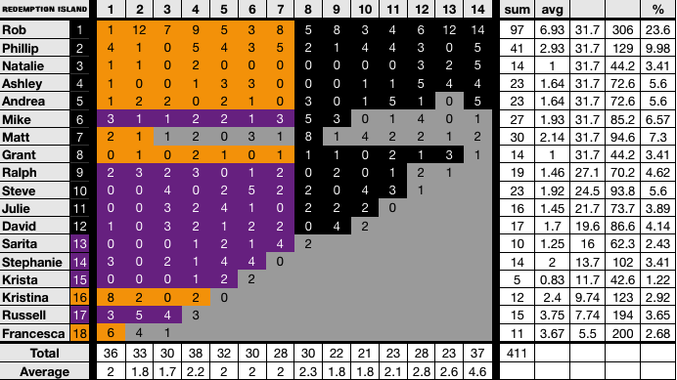

**Differences**

Most changes were accepted except for:

* All Redemption Island post-credit confessionals were not included (-13).
* Even though Rob got a total of 97 confessionals, same as mine, there are two differences:
  + Confessional #24 from Ep3 was an on-the-fly confessional that was not counted so he got 7 (-1).
  + Confessional #18 from Ep4 had one on-the-fly segment that I included but was disregarded so he remains at 9 (+1).